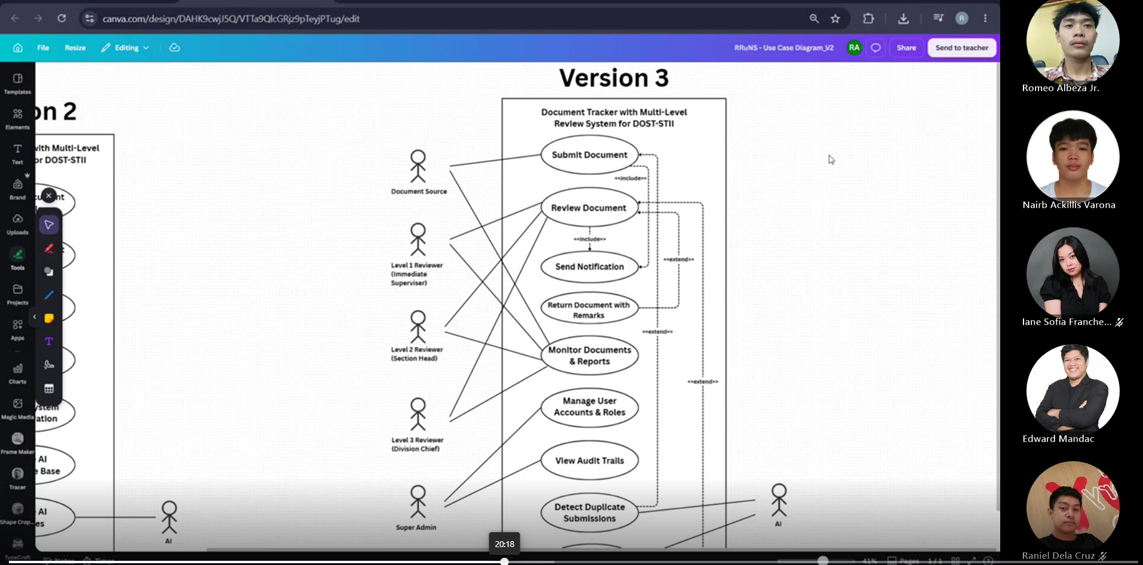
Weekly Status Report: Minutes of Meeting
- Date: August 10, 2026
- Meeting Called By: RRuNS Team
- Facilitator: Edward Mandac
- Link of the Meeting: RRuNS – RRuNS - Weekly Status Meeting-20260810_181521-Meeting Recording.mp4

1. Attendees
- Nairb Ackillis Varona
- Romeo Jr. Albeza
- Iane Sofia Francheska Padua
- Raniel Q. Dela Cruz
2. Agenda
- Discussion of use case diagram
- Set a meeting with client for further questions about the use case
3. Summary
- Status update for the week:
  - The team conducted a detailed discussion regarding the layout, structure, and components of the use case diagram.
  - Plans were established to coordinate and schedule a direct meeting with the client to clarify specific workflow details and address further questions regarding the use case requirements.
- Blockers/Obstacle that encountered this week:
  - None

